**What is the advantage of docker or why we use it?**

1. Environments standardization

2. build it once and deploy it anywhere

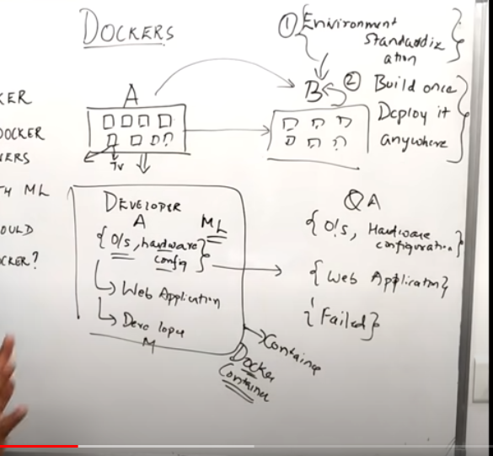

**Virtual machine VS Docker:**

* In VM we cant use the resources of v1 into v2 and v3. But in docker we use the resources of D3 in D1 and D2.
* Isolation and portability

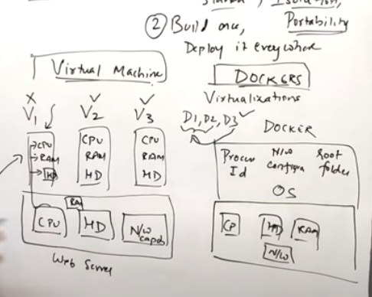

**Docker with ML:**

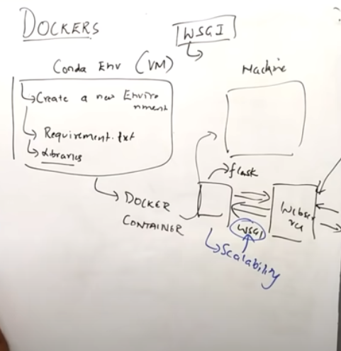

**Docker commands:**

